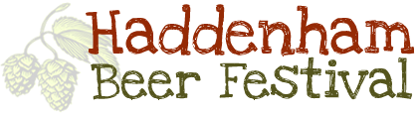
Donation Request Form – 2026
Closing Date for Requests Sunday 28 June

Supporting the Festival

Our festival relies on community involvement to succeed, and we welcome support from applicant organisations in ways that are appropriate to their capacity and circumstances.

Support might include, for example:
- Volunteering or helping at the festival (where appropriate)
- Hosting or contributing to a stall, talk, or activity
- Assisting with setup or takedown (Setup Wednesday 24 June – Friday 26 June, takedown Monday 29 June)
- Supporting festival promotion or community engagement
- Providing planning, administrative, or professional support
- Contributing at another time or in a non-physical way

We recognise that some organisations, particularly those led by or supporting people with disabilities or health conditions, may not be able to offer physical or in-person support. This will not disadvantage an application.

Please outline any support your organisation may be able to offer, if appropriate:

Please complete the following contact information:
Name of Organisation:
Address:
Postal Code:
Contact Name:
Contact Number:
Email:
Charity number (where applicable):

Request for Donation
Summary of Request:
Amount required:
Who will benefit:

Short Description of Organisations Aims and Objectives:

Please email the completed form by Sunday 28 June to treasurer@haddenham.beer.

